Chapter 19, Solution 32.

Using Fig. 19.90, design a problem to help other students to better understand how to find the h and g parameters for a circuit in the s-domain.

Although there are many ways to solve this problem, this is an example based on the same kind of problem asked in the third edition.

Problem

Find the h and g parameters of the two-port network in Fig.19.90 as functions of s.

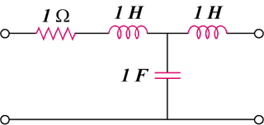

Figure 19.90

Solution

- We obtain 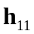 and 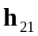 by referring to the circuit in Fig. (a).
s
1/s
1
I₁
(a)
I₂
+
V₂ = 0
−
+
V₁
−
s

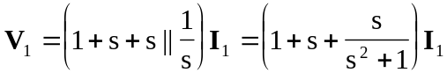
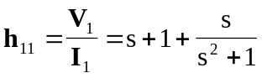

By current division,
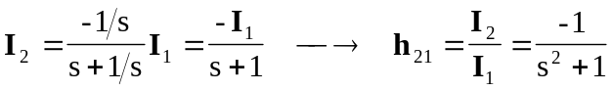

To get 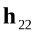 and 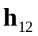, refer to Fig. (b).
s
1/s
1
(b)
I₂
+
V₁
−
s
V₂
I₁ = 0
+
−

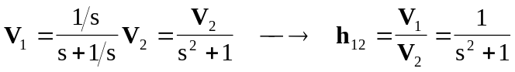

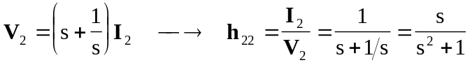

Thus,
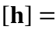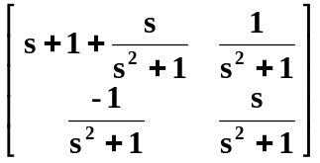

- To get 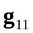 and 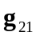, refer to Fig. (c).
s
1/s
1
V₁
(c)
+
V₂
−
s
I₂ = 0
+
−
I₁

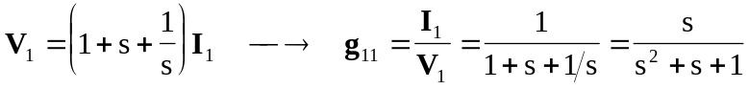

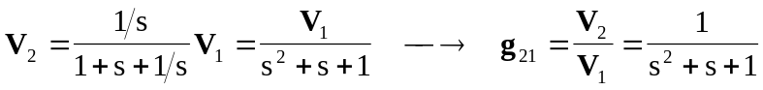

To get 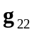 and 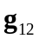, refer to Fig. (d).
s
1/s
1
(d)
s
I₂
+
V₁ = 0
−
I₂
+
V₂
−
I₁

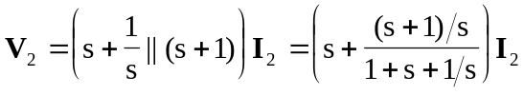
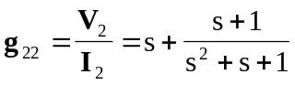

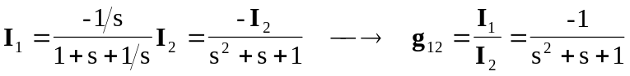

Thus,
